

**STANDARD OPERATING PROCEDURE**

**Do not Photocopy**

**Document Information Classification: Unrestricted**

|  |  |
| --- | --- |
| **Title:** | **Bringing Assets into the TRE** |
| **Effective Date:** | **30 Sep 2019** |
| **Reference Number:** | **SOP-05-01** |
| **Version Number:** | **2.10** |
| **Owner:** | **Information Security Manager,** |
| **Review Date:** | **30 Sep 2021** |

Table of Contents

1. Purpose 3

2. Scope 3

2.1. TRE Assets 3

2.2. CHI Assets 3

2.3. Out of Scope 4

3. Responsibilities 4

4. Procedure 4

4.1. Introducing Assets to the TRE 4

4.2. Asset Registers 4

4.3. Asset Owners and Registers 5

4.4. Initiation of Process 6

4.5. Adding Assets to the Q-Pulse Asset Module Register 6

4.6. TRE Dataset Registration 6

4.6.1. Raw Datasets 6

4.6.2. Derived Datasets 7

4.6.3. Other Datasets 7

4.6.4. Digital Signatures 7

4.7. Software 7

4.7.1. Software Categorisation 7

4.8. Appropriate Use, Licensing and Intellectual Property 8

5. Cross-referenced ISMS Documents 8

6. Appendices 9

6.1. Q-Pulse Guidelines for Creating Asset Records in the Asset Module 9

6.1.1. Creating a New Asset 9

6.2. Asset ID Prefixes 11

6.3. Asset Type Master List 11

1. Purpose

Assets associated with information and information processing facilities should be identified and owned and an inventory of these assets should be maintained. The introduction of new assets into the Trustworthy Research Environment (TRE) needs to be managed to ensure that each asset is added to the inventory in a standardised way. It is also desirable for CHI to keep similar records for all of its portable electronic devices to support asset management throughout the organization.

This document defines the asset types for both TRE and non-TRE assets, the owners for each asset type and the procedure for registering the details of assets.

TRE Assets are any tangible or intangible element that has a value to the TRE and its ongoing operations, and which are crucial to TRE data. Loss or malfunction of that asset would result in a direct threat to TRE operations and possibly data security. Each of the assets will be handled in a specified way and will be assigned an information classification and controls necessary to protect the security of the asset and the asset’s information.

1. Scope
   1. TRE Assets

The following asset types are classified as TRE assets and are in scope for this procedure:

* **Information Assets – TRE Data**: Structured (databases), Semi-structured (image, audio, video files, machine/disk images, software code, bit streams) Unstructured (text, csv). Includes: all data imported into the TRE that is to be accessed by members of TRE research projects; raw datasets provided by the TRE project’s appointed Data Controller which are referenced on the project’s data sharing agreement or contract.
* **Information Assets - System information**: User accounts, Audit trails, System configuration.
* **Software Assets**: Operating systems, Software applications, Testing tools, Development tools and utilities.
* **TRE Infrastructure**: Servers, Storage devices, Network devices, Backup power.
* **Physical assets**: Building infrastructure, Security controls.
* **Services**: IT and Communications services, University Estates (e.g. mains electrical, cooling), University Security (door access control).
* **People**: TRE Staff, TRE Users, Standalone Application Server system-administrators.
  1. CHI Assets

The following asset types are classified as CHI assets and are also in scope for this procedure. However, the management of these asset types has no direct impact on the TRE and can be considered ‘best-efforts’.

* **Information Assets - Documents**: Policies, Procedures and Process, system documentation and configuration, user manuals, training materials, operational or support documents, business continuity plans, data inventories, research information, contracts and agreements.
* **Portable electronic devices**: All CHI laptops, tablets and mobile phones.
* **People**: CHI Staff and Students
  1. Out of Scope

This SOP does not cover intangible assets such as reputation, customer satisfaction and public image, although failure to manage the assets listed above could impact on these intangible assets.

Files created by members of the TRE project are out of scope. Examples of such files are data processing scripts, analytical code and tabulated data.

A composite dataset that contains a very large number of constituent files is also out of scope. In such cases, only the ‘parent’ composite file requires an asset record.

1. Responsibilities

CHI Staff Administration or the TRE Operations Team is responsible for:

* Adding assets to the appropriate register in Q-Pulse

The Asset Owner is responsible for:

* The lifecycle of an asset including acquisition, record keeping, usage, maintenance, and the return or decommissioning of the asset.

Asset Process Owner

* Approving the addition of new asset types and asset locations.

Q-Pulse Administrator

* Adding new asset types and asset locations to Q-Pulse

TRE Operations are responsible for:

* Managing TRE Data assets

1. Procedure
   1. Introducing Assets to the TRE

It’s essential that the Q-Pulse asset registers reflect the exact status of the TRE assets. The introduction of any infrastructure or software assets into the TRE must follow the TRE Change Control procedure (SOP-03-08).

* 1. Asset Registers
* **Q-Pulse Assets module**: should be used for TRE Infrastructure and TRE Datasets, all buildings, equipment, utilities, software, services, and their associated contacts and maintenance records;
* **Q-Pulse Documents module**: should be used for all draft and approved documented information listed on the document type list. This includes all policy, SOPs, templates and management documents; it does not include completed forms or records – these will be stored against the appropriate asset record.
* **Q-Pulse TRE Projects module**: should be used for all projects that use the TRE, the datasets belonging to that project stored in the TRE, associated TRE User Accounts, Data Sharing agreements and Ethics agreements (files attached to TRE Project record)
* **Q-Pulse People and TRE Users module**: should be used for all TRE staff, students and all TRE user account holders
* **Q-Pulse Training and Qualifications module**: should be used for all training records, training evaluations and training requirements, scanned copies of confidentiality agreements.
  1. Asset Owners and Registers

All assets are assigned an Asset Owner based upon the specific details of that asset. The Asset Owner has overall responsibility for the lifecycle of an asset including acquisition, records keeping, usage, maintenance, and the return or decommissioning of the asset. The asset may be assigned to a different individual who has the actual possession of the asset and is responsible for its day-to day usage.

The following table shows which ISMS role has overall responsibility for each asset type and the location of the Asset Register that must be used for recording the details of each asset type.

|  |  |  |
| --- | --- | --- |
| **Asset Type** | **Asset Owner** | **Asset Register Location** |
| Access Control | Information Security Manager | TRE Infrastructure Record |
| Dataset | TRE Data Manager | Q-Pulse Assets module (associated with a record within the Q-Pulse TRE Projects module) |
| Documentation | Information Security Manager | Q-Pulse Documents module |
| People – CHI Staff | Head of Operations CHI | Q-Pulse People and TRE User Accounts module |
| People – TRE Staff and TRE Users | TRE Operations Process Owner | Q-Pulse People and TRE User Accounts module |
| Personal Computing Hardware | Head of Operations CHI | Q-Pulse Assets module |
| Physical Assets - Vaughan House Infrastructure | Head of Operations CHI, Information Security Manager | Q-Pulse Assets module |
| Software (TRE) | TRE Operations Process Owner / TRE Infrastructure and Security Management Process Owner | Q-Pulse Assets module |
| Training/Skills | Staff Training and Competency Process Owner | Q-Pulse Training and Qualifications module |
| TRE Infrastructure | TRE Infrastructure and Security Management Process Owner | Q-Pulse Assets module |
| TRE Service | TRE Operations Process Owner / TRE Infrastructure and Security Management Process Owner | TRE Infrastructure Record, corresponding TRE hardware: Q-Pulse Assets module |
| Services Provided to TRE | TRE Operations Process Owner | Q-Pulse Asset module and Customer module |

The remainder of this document only defines the process for adding assets to the Asset Module in Q-Pulse. The processes for adding the assets recorded in other asset registers are managed through different procedures.

* 1. Initiation of Process

Depending upon the asset type or specific asset, the process for adding an asset to its asset register will be initiated at different stages of the asset lifecycle. These stages are summarised below.

|  |  |  |
| --- | --- | --- |
| **Asset** | **Initiation Stage** | **Group Responsible** |
| TRE Data Access | Submission of FORM-002 | TRE Operations |
| TRE Dataset | Completion of SOP-05-03 | TRE Operations |
| TRE Infrastructure – Data Storage | Submission of FORM-002 | TRE Operations |
| TRE Infrastructure – Virtual Server | Submission of FORM-002 | TRE Operations |
| Documentation – Data Sharing Agreement | Submission of FORM-002 | TRE Operations |
| Software | After purchase approval | TRE Operations |
| IT Hardware - TRE Infrastructure | After purchase approval | TRE Operations |
| Personal Computing Hardware | After purchase approval | CHI Staff Administration |
| Services Provided to TRE and TRE Infrastructure/Utilities | After purchase approval | TRE Operations |
| Physical Assets - Vaughan House Infrastructure | Determined by asset type | TRE Operations |

* 1. Adding Assets to the Q-Pulse Asset Module Register
* At the appropriate initiation stage, the group responsible (CHI Staff Administration or TRE Operations) will identify the necessary details of the asset and create the asset record in Q-Pulse.
* Following the actual delivery or installation the group responsible will collect the additional details of the asset (e.g. serial number) and complete the update of the Q-Pulse record.

Note: the addition of details for a TRE asset is mandatory and these records will be reviewed as part of any audit process. The addition of details for a CHI Asset is ‘best-efforts’ and the records will not be included in any process audit.

* 1. TRE Dataset Registration
     1. Raw Datasets

Raw datasets should only be added as an asset and imported into the TRE if the Data Sharing Agreement/Contracts lists those datasets and specifies the TRE as the place of storage.

Raw data describes the type of data created by a data processor that contains information derived from population health records. This is can be an extract from a very large dataset, and as such may be a unique dataset that is not stored elsewhere.

Data imported into the TRE is recorded in the asset register, with the type ‘Raw dataset stored in TRE’.

* + 1. Derived Datasets

Data created within the TRE (the project’s derived or secondary data) will only need to be added to the asset register if the data has been archived within the TRE’s long-term storage facility, for example to support future studies. Such data needs to be added to the asset register using the type ‘Processed/Derived data stored in the TRE’. It is likely that such data will also be referenced in a research data catalogue to facilitate discovery and re-use.

* + 1. Other Datasets

TRE users sometimes need to import other types of data into the TRE to allow them to conduct their analysis and processing, for example data processing scripts, analytical code and tabulated data published by healthcare providers. In general, these are often not unique, as the person who created them will have a copy elsewhere. This means it is not normally necessary to add these files to the asset register.

* + 1. Digital Signatures

In addition to descriptive information about RAW TRE datasets, it is also necessary to record a digital signature for each file. This helps the TRE service meet its objective to retain evidence that no loss in data integrity has occurred. The digital signature is generated using an SHA256 checksum by the person conducting the data import. A copy of the checksums for all datasets is recorded alongside those data within the TRE storage system, but additionally, the checksum values are recorded within the asset register to provide second form of information backup.

* 1. Software
     1. Software Categorisation

TRE software is categorised by the following types:

* Core TRE infrastructure software – Microsoft/Linux operating systems for the admin nodes, hypervisors and virtual machines, applications used to manage the overall ‘cloud’ environment, network device operating systems
* Scientific Software – commonly used scientific applications installed on virtual workstations for conducting analysis and processing of raw data

Particular attention must be paid to the installation of software, despite it sometimes being Business as Usual (BAU) as there may be commercial licenses and usage agreements that must be managed accordingly. The Intellectual Property Policy (ISMS-05-10) describes the measures that must be taken in ensuring correct use and implementation of software and licenses. There is always a risk involved in installing software, therefore the Change Control procedure (SOP-03-08) must be followed so that a risk assessment is formally conducted and the require reviewing and approval processes followed.

The ‘Software’ worksheet within the TRE Infrastructure Record details the formal request and installation of all ‘non-BAU’ software installation onto TRE project virtual workstations.

All software assets registered in Q-Pulse must have details of commercial licenses attached to the record. It is not necessary to record open source software as a Q-Pulse asset, unless there is a particular reason it needs to be referenced as an official TRE asset.

It is also important to keep a record of software usage in cases where the license restricts the amount of concurrent users. This is achieved by recording within the ‘Notes’ section of the Q-Pulse asset record, the number of users of each TRE project that has access to that particular software asset (if it has been installed on their virtual workstation). The Routine measurement and monitoring for the TRE Asset and Supplier Management process includes a check of the ‘Notes’ sections for each software asset recorded in Q-Pulse.

* 1. Appropriate Use, Licensing and Intellectual Property

Prior to the acquisition of a TRE asset, it must be ensured that any licenses or contracts specifying acceptable usage policies are appropriate for the use of that asset within the TRE environment. The following are examples of asset usage that must be considered:

* Software Licenses. Open Source software doesn’t not require a license in most cases. Some software products are made available with an ‘evaluation’ or ‘trial’ license, which are appropriate for development activities. Use of evaluation licensed software in a production environment could contravene the terms of that license, and therefore a full production software license must be obtained.
* Hardware acceptable use/warranty agreements. Some hardware products specify the environmental requirements, and their warranties could become invalidated if they are used in certain conditions, e.g. adverse temperature.
* IP agreements. It is possible to breach IP agreements through inappropriate implementation and use of an asset. For example, extracting a component of a software product, or re-purposing a hardware product could be seen as infringement of the asset supplier/manufacturer’s IP policy.

Note, the ISMS has an Intellectual Property Policy (ISMS-05-10) but this is only applicable to material created by members of the University of Manchester (UoM), and does not apply to 3rd party products acquired by the UoM.

1. Cross-referenced ISMS Documents

|  |  |  |
| --- | --- | --- |
| Number | Type | Title |
| FORM-002 | ISMS\Forms | TRE Project Application Form |
| SOP-05-03 | ISMS\SOP\Asset and Supplier Management - SOP | Importing Content into the TRE |
| FORM-005 | ISMS\Forms | Request for Access to Vaughan House Secure Zones and Security Resources |
| REC-001 | ISMS\Record | TRE Infrastructure Record |
| SOP-03-08 | ISMS\SOP\TRE Operations - SOP | TRE Change Control |
| ISMS-05-10 | ISMS\Policy & Guidance\Asset and Supplier Management - policy & guidance | Intellectual Property Policy |

1. Appendices
   1. Q-Pulse Guidelines for Creating Asset Records in the Asset Module

Only CHI Staff Administration or the TRE Operations team can create new assets within the Q-Pulse Assets module. This section describes in further detail the steps necessary to complete these responsibilities.

* + 1. Creating a New Asset
* To create a new asset, open the Asset Module and click on  and select ‘New Asset’. Note: ‘New Asset Based On’ may be used if you first select an asset with similar properties as the asset you want to create (e.g. you may select a portable device and use “New Asset Based on” if you want to create a new portable device.
* You will then see a new asset record card (example shown below)

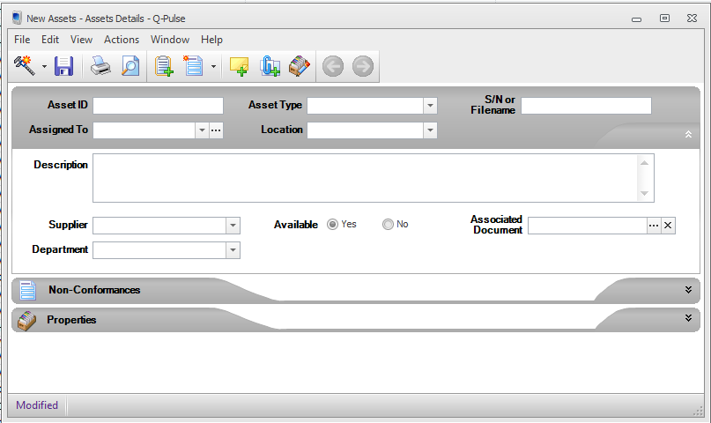

* **Asset ID:** unique alpha-numeric ID used to identify individual assets
* **Assigned To:** the person who has possession of the asset and is responsible for its usage.
* **Asset type:** Select the most appropriate asset type from the dropdown list (see section 6.2 for detail of the asset type master list)
* **Location:** the room/area in which the asset can be found. For TRE data this is always ‘Vaughan House | Ground Floor | Server Room (TRE)’
* **S/N:** the asset’s serial number (put “N/A” if not applicable). For TRE data this will be the full filename, including the extension.
* **Description:** A summary of the asset information, any projects the asset belongs to and any supporting information. For TRE data include the project name e.g. TRE-010 at the start of the section.
* **Supplier:** Either type in or select the supplier (manufacturer) from the list. If the supplier doesn’t already exist it can be added to the list.
* **Department:** where appropriate, select the department to which the asset belongs
* **Available:** Yes/No – Set to ‘No’ if the asset is assigned and being used. If ‘No’ is selected a reason will need to be selected from the dropdown list. For some items held in stock or for long-term loan, e.g. laptops, it’s possible that the asset will be assigned to a person, but could still state ‘Yes’ in the available section to indicate the item hasn’t been loaned out yet.
* **Associated document:** The asset can be linkedto an active document in Q-Pulse – e.g. maintenance document/user guide.
* **Properties:** Expand the section and click to view the available fields. The properties section should be used to record any additional information that is useful for the asset – this may include attaching manufacturer’s documents/URLs, or the IP address and purchase date. For TRE data copy the SHA256 checksum generated within the TRE as a record of that file’s digital signature. **Assets that directly handle TRE Data, or have the potential to compromise its confidentiality are deemed to be critical and must be assigned “Yes” in the “Critical Asset” field.**

Note: If a new asset type or asset location is identified the CHI Staff Administration team will inform the Asset Process Owner who will confirm whether the new details can be added. If approved the CHI Staff Administration Team will request the Q-Pulse Administrator to add the new asset type or location.

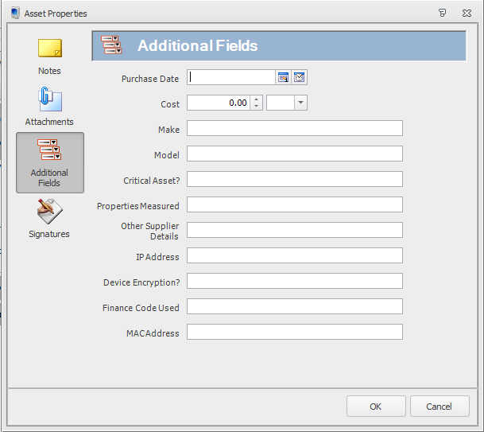

* Once the additional fields have been updated click on ‘OK’ to return to the asset record card.
* Once all listed sections are complete on the record card, click  to save the record card and then the record cared can be closed.

This completes the actions necessary to add a new asset.

* 1. Asset ID Prefixes

The following table defines the prefixes that should be used in assigning asset IDs.

|  |  |
| --- | --- |
| **Prefix** | **Applies To** |
| TRE-COOLING | Cooling |
| TRE-Data | Processed/Derived dataset stored in TRE |
| TRE-Data | Raw dataset stored in TRE |
| TRE-HDD | (HDD) Data Storage |
| TRE-INF | Firewall |
| TRE-INF | Physical Server |
| TRE-INF | Power Backup |
| TRE-INF | Network Device (includes switches, routers, VPN appliance) |
| TRE-Key | Mechanical lock key |
| TRE-PW | Account Information |
| TRE-SAFE | Safe |
| TRE-SERVB | Services provided by TRE |
| TRE-SERVT | Services provided to TRE |
| TRE-STOR | Data Storage (inc HDD, USB) |
| TRE-SW | Core TRE infrastructure software |
| TRE-SW | Scientific Software for TRE Projects |
| TRE-SW | TRE Hosted Software Applications |
| TRE-USB | (USB) Data Storage |
| CHI | CHI (Non-TRE) Assets |
|  |  |

* 1. Asset Type Master List

The following is the master list of all assets types. Those that relate to the TRE are highlighted. The hierarchical asset list within the Q-Pulse Asset Module must reflect the list within this section.

* Access Control
  + **Account Information**
  + **Mechanical lock key**
  + **Safe**

* **Dataset** 
  + **Processed/Derived dataset stored in TRE**
  + **Raw dataset stored in TRE**
* Personal Computing Hardware
  + CHI Laptops
  + Smartphone
  + Tablet/iPad
* **Service** 
  + **Service provided by TRE** 
    - **Data analysis**
    - **Data Back up**
    - **Dataset storage**
  + **Service provided to TRE** 
    - **Janet Network**
    - **N3 Network**
* **Software** 
  + **Core TRE infrastructure software**
  + **Scientific Software**
  + **TRE Hosted Service Applications**
* **TRE Infrastructure** 
  + **Cooling**
  + **Data Archiving**
  + **Data Storage**
  + **Firewall**
  + **Network Device**
  + **Physical Server**
  + **Power Backup**